No. of Pages | 3
No. of Questions | 3

Department of Computer Science and Engineering
MIDTERM EXAMINATION Summer 2017

CSE421: Computer Network
Total Marks: 45 Time Allowed: 55 minutes
- Answer ALL THREE (3) questions
- Figure in bracket [] next to each question indicates marks for that question

Question 1
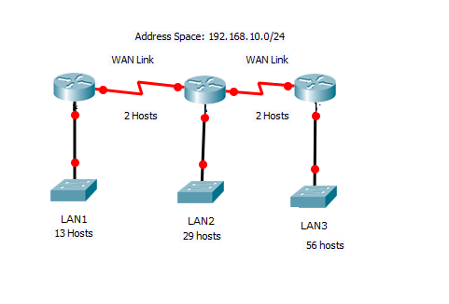
Figure no. 1

- Suppose a company is given a block 192.168.10.0/24. But you need three more sub networks for your organization and two more for the WAN Links as shown in figure no. 1. Show how you can have 5 more subnets out of the original network address as per host requirements. Do not forget to show basic calculations. [8 marks]

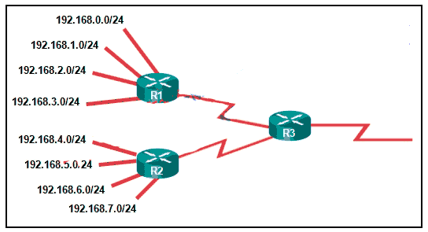
Figure no. 2

- Refer to the topology in Figure 2. What should be the static summary routes and where should we apply them? [4 marks]
- A router has the following information regarding the network 172.17.10.0/24, which one will it use to routes packets to that destination and why? [3 marks]
  - S 172.17.10.0/24 [1/0] via 200.20.20.1
  - S 172.17.10.0/24 [5/0] via 201.21.20.1
  - R 172.17.10.0/24 [120/4] via 202.22.20.1

Question 2

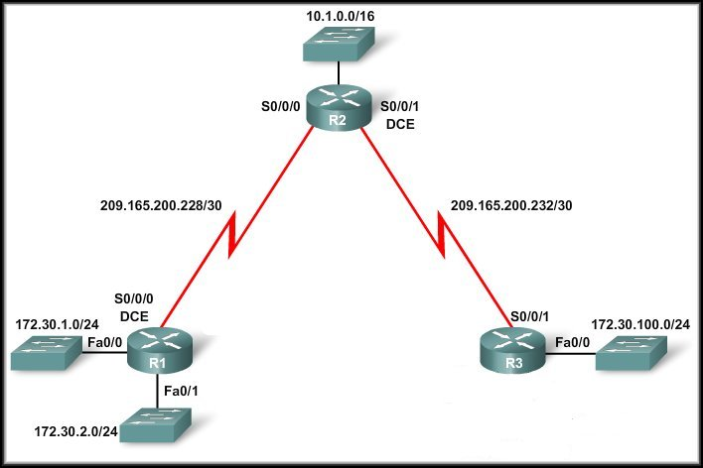
Figure no. 3

- Given Figure no.3 shows a discontiguous network. The Auto-summary must be disabled. Now write down the process in full for disabling the auto-summary. [4]
- Write down the difference between RIPv1 and RIPv2. Define different types of timer for RIP. [3+3=6]
- What is the process (commands) for static summary route in RIP routing? Why we use passive Interfaces? [3+2=5]

Question 3

- Two routers is in TWO-WAY state and they have just started exchanging their link state packets/DBD packets. Name the states that the routers go through till full convergence occurs. [4 marks]
A routing table of Router A contains the entry:
192.168.3.0/24 [110/65] via 192.168.1.2, 00:00:20, Serial0/0

- Router A’s serial 0/0/0 operates at 64kbps. The bandwidth and cost commands are not used. Is the calculated OSPF cost for the link correct? [4 marks]

- Refer to the multi access networks shown in figure no. below. For each router find their router ID. And also find the DR/s and BDR/s. [3+4 marks]
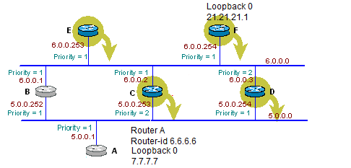

THE END
Figure no. 2

